**GIS5572 Quiz 3**

1. In a sentence, what is a network?

A set of connected edges and nodes that can have an assigned direction. It is used to generalize space

1. What common spatial data type are networks often derived from?

Polylines

1. What are three different ways that networks can be represented? (use diagrams)

Abstracts, table, network

1. What is the relationship between networks and graphs?

The graph is the abstract structure that the network is represented by.

1. For the following link table, fill out the edges and draw a graph:

|  |  |  |
| --- | --- | --- |
| Edge | Start Node | End Node |
| L1 | F | G |
| L2 | G | D |
| L3 | D | F |
| L4 | G | F |
| L5 | A | A |

Graph Drawing:

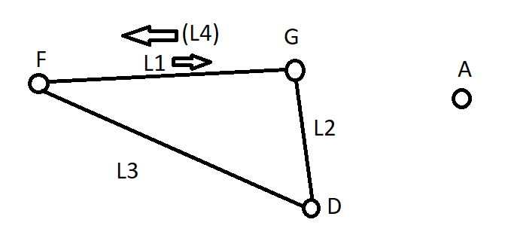

1. What are spatial interaction models?

A spatial interaction model shows how a phenomenon interacts with a network in space (How does the water flow over the rocks)

1. What is the classic gravity model?

Trips equals K times the respective sizes of origin and destination, over the distance between origin and destination. Effectively treats endpoints as masses in gravity equation.

1. What is the huff model?

Expanded gravity model. Size is translated into attractiveness. The ‘attractiveness’ of each destination is standardized to give comparative probabilities. Distance stays.

1. Compare and contrast the gravity model and the huff model.

Gravity model is not standardized. Huff is by summing all attractiveness/distance measures.

Gravity uses ‘size’ of endpoints, Huff uses attraction measure

Gravity is a poor representation of human decisions, Huff is better.

1. Describe the types of processes that spatial interaction models can represent. Choose one of your examples to create a verbal description of how a spatial interaction model of the phenomena could work.

Migration, disease, transportation

I suppose like a COVID contact tracing network? That would be a network type problem because each infected node would diffuse to connected nodes at a certain rate and probability. Infection could also be traced in reverse to the source node.